

|  |
| --- |
| **Marks obtained:** |
| **Total:**  **30** |

**MONTHLY TEST FEBRUARY-2020**

**Name: ____________________________**

**Grade: I Section___**

**Subject: MATHS**

**Date: 21.02.2020**

**Time: 1 Hour**

**I. Choose the correct answers. 10x1=10**

1. A design that gets repeated is called a ______________

a. rupee b. patterns c. money

2. We always subtract the smaller number from the____________ number.

a. lesser b. small c.bigger

3.________________ is used to buy things.

a. Money b. toys c.numbers

4. 21—5 = __________

a. 19 b. 20 c. 16

5.Money is used in the form of _______________

a. notes and coins b. food and water c.eyes and ears

6.75 -- 15 ____________

a. 50 b. 60 c.70

7. The pens are arranged as red, green,yellow, red, __________, yellow.

a. yellow b. red c. green

8.Complete the patterns

­­­­ _______

a. b. c.

9. 30 – 1 = _________

a. 28 b. 27 c. 29

10. Indian currency symbol is _______

a. £ b. c.®

**II. Fill in the blanks. 6x1/2=3**

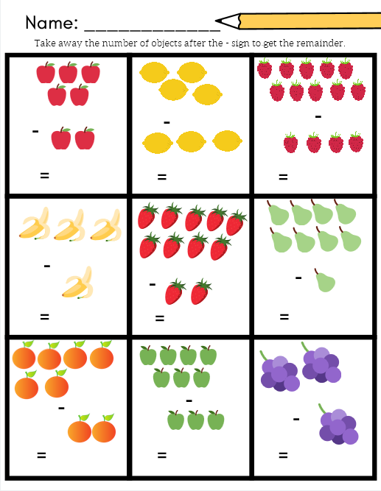

**III. Draw the missing picture**. **4x1=4**

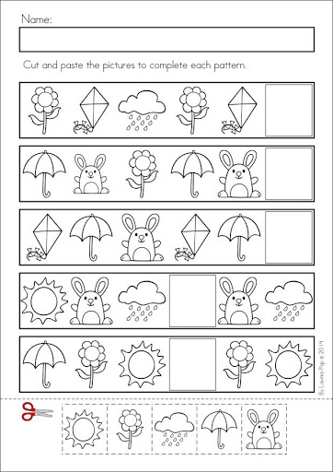

**IV. Draw the patterns in the following. 2x 2 ½ =5**

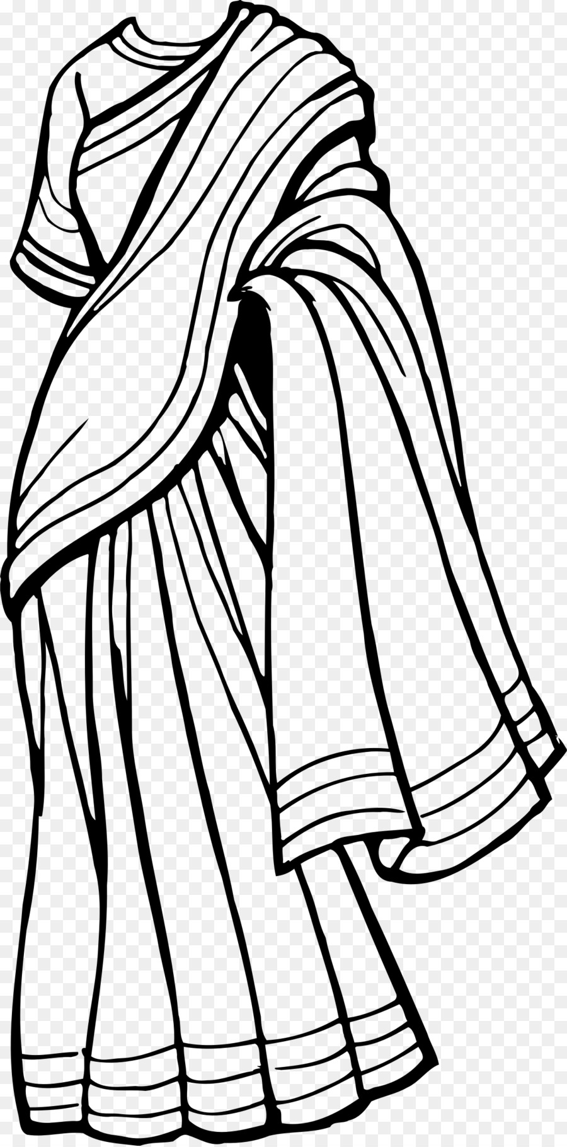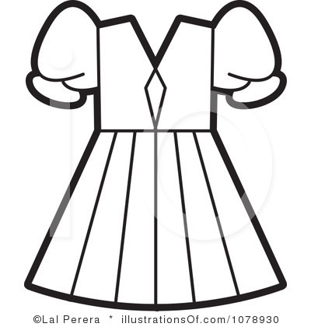

**V. Complete the following. 4x1=4**

11. Rs 10 + Rs 5 = _________________

12. Rs 20 + Rs 2 = _________________

13. Rs 100 + Rs 100 = _________________

14. Rs 2 + Rs 1 = _________________

**VI. Draw the amount using notes and coins. 4x1=4**

|  |  |
| --- | --- |
| 5 |  |
| 10 |  |
| 200 |  |
| 50 |  |